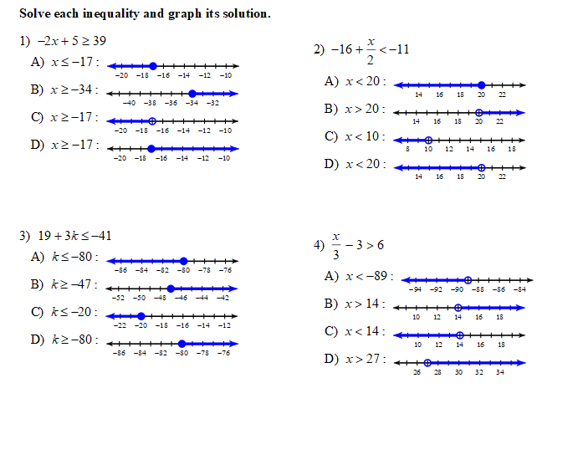
Week 4 - Solving Inequalities ACT 10
5.

A. x < z
B. x > 0
C. Nont of the above answers
D. x = z
E. x > z

