1. 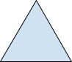What is the rotational order and degree of rotation
F. 3, 120 degrees G. 3, 60 degrees H. 1, 120 degrees J.1, 360 degrees K.4, 90 deg.

2. How many lines of Symmetry in an Octagon?

A. None B. 2 C. 4 D. 8 E.10.6
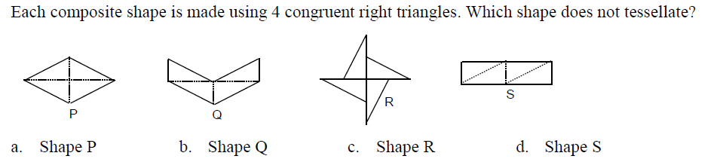
3.
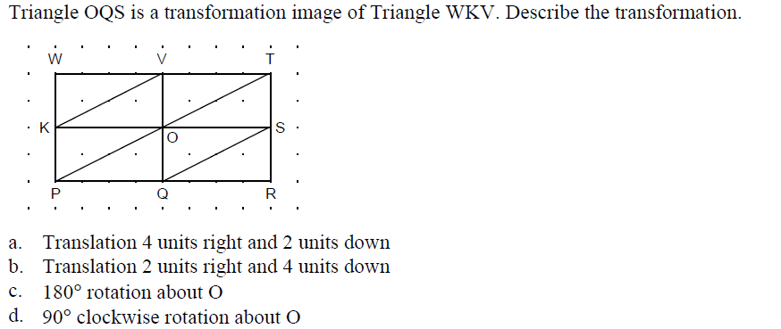
4.

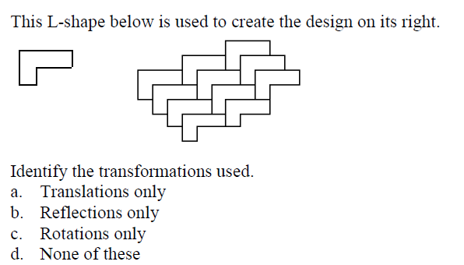
5.

