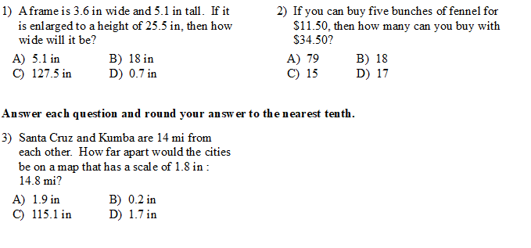

4. The length and breadth of a rectangle are in the ratio 3 : 1. If the breadth is 7 cm, then the length of the rectangle is:

A. 14 cm B. 16 cm C. 18 cm D. 21 cm E. 30 cm

5. What ratio is equal to 15:20
F. 5 to 10 G. 18:25 H. 18, ⅔ J.18, 3/2 K. -18, -⅔

