1. Working alone at its constant rate, machine A produces k liters of a chemical in 10 minutes. Working alone at its constant rate, machine B produces k liters of the chemical in 15 minutes. How many minutes does it take machines A and B, working simultaneously at their respective constant rates, to produce k liters of the chemical?
A. 0 B. 3 C. 4 D. 5 E. 6
2. Which of the following could be the units digit of 57^{n}, where n is a positive integer?
F. 0 G.2 H. 4 J.5 K. 9

3. Quantity A: 54% of 360
Quantity B: 150

A. Quantity A is greater. B. Quantity B is Greater C. Both are Equal D. The relationship cannot be determined E. None of the above

4.Which cube can be made from this pattern
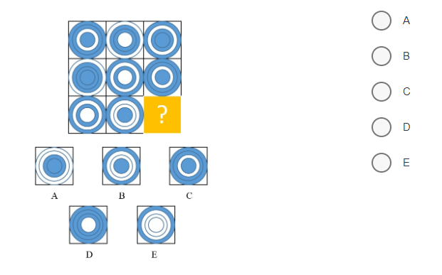
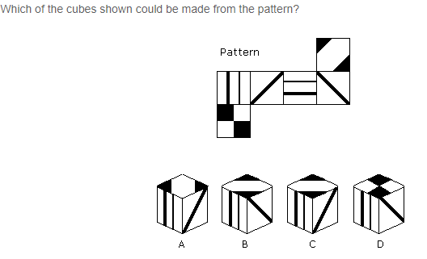
5. What image is the missing Square?

